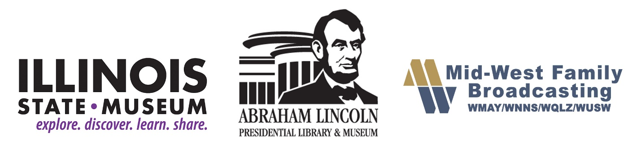

**On the air with 365 days of Illinois history**

*Presidential library, State Museum and Mid-West Family Broadcasting to present Illinois Bicentennial Minutes*

SPRINGFIELD – To celebrate the state’s 200th birthday and explore its amazing history, the Abraham Lincoln Presidential Library and Museum, Mid-West Family Broadcasting and the Illinois State Museum are teaming up to present “bicentennial minutes” throughout 2018.

The daily radio spots highlight key people, events and dates in Illinois history, from triumphs like Lincoln’s election as president to tragedies like the sinking of the S.S. Eastland, which killed 844 people. Listeners will meet heroes, activists and pioneers, including:

* The governor who never visited the state Capitol
* A woman who put the national spotlight on lynching
* The man who changed the shape of Illinois
* The tallest man in history
* A legendary gunslinger

“We’re excited about the many different ways we get to help celebrate the bicentennial. This partnership with Mid-West Family Broadcasting and the Illinois State Museum promises to be a great way of reaching the public with stories they may never have heard before,” said Alan Lowe, executive director of the Abraham Lincoln Presidential Library and Museum.

The Lincoln Presidential Library is also the state’s official historical library, home to documents, newspapers, photographs and artifacts that tell the story of Illinois.

The Illinois State Museum’s Illinois Legacy Collection includes more than 13.5 million objects documenting Illinois’ life, land, people and art from 500 million years ago to today.

Illinois State Museum Director Dr. Michael Wiant stated: “The bicentennial provides an extraordinary opportunity for collaborations that illustrate the diverse and broad story of Illinois to its citizens. We’re thrilled to kick off another collaborative effort with the Lincoln Presidential Library and Museum and Mid-West Family Broadcasting.”

Harvey Wells, general manager for Mid-West Family Broadcasting in Springfield said: "On behalf of all the employee-owners of the Mid-West Family radio stations in Springfield and Rockford, we are thrilled to be able to provide content that celebrates the rich history of our state. I would like to thank WMAY News Director Jim Leach and our Creative Services Director Johnny Molson along with the Abraham Lincoln Presidential Library and Museum and the Illinois State Museum for their dedication in creating 365 unique daily features.”

“I would also like to thank Dennis Lyle and the Illinois Broadcasters Association for offering them at no-charge to radio stations throughout our state," Wells added.

The spots will be available to radio stations throughout the state through the Illinois Broadcasters Association, which is sending out download information.

You can find the Lincoln Presidential Library at[www.PresidentLincoln@illinois.gov](http://www.PresidentLincoln@illinois.gov/) or on [Facebook](https://www.facebook.com/Lincoln.Museum/), [Twitter](https://twitter.com/ALPLM) and[Instagram](https://www.instagram.com/lincolnmuseum/).

Learn about the State Museum at [www.illinoisstatemuseum.org](http://www.illinoisstatemuseum.org/).

Visit Mid-West Family Broadcasting at [www.wmay.com/illinois200](http://www.wmay.com/illinois200)

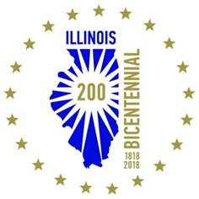**Contacts:**

Lincoln Presidential Library

Christopher Wills

217-558-8970

[chris.wills@illinois.gov](mailto:chris.wills@illinois.gov)

Illinois State Museum

Karen Everingham  
217-782-5949  
[karen.everingham@illinois.gov](mailto:karen.everingham@illinois.gov)

**# # #**