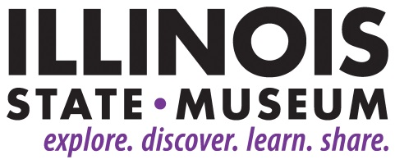

**FOR IMMEDIATE RELEASE**

9/5/18

**Contact:**

Elizabeth Bazan

[Elizabeth.Bazan@Illinois.gov](mailto:Elizabeth.Bazan@Illinois.gov)

217-558-6696

**Illinois State Museum Society Offering Travel Opportunity to Rock Island, Moline**

SPRINGFIELD, IL – The Illinois State Museum Society, the membership organization of the Illinois State Museum, is resuming educational travel opportunities, beginning with a fall trip to the communities of Rock Island and Moline. The Oct. 26-27, 2018 motor coach trip will focus on the cultural geography and history of these cities, located at the confluence of the Rock and Mississippi rivers. The trip will also emphasize the role of agriculture-related manufacturing in Illinois in developing the state’s urban areas, as well as increasing production on farmland.

Dr. Norman Moline will be the guide for the two-day tour of historic, environmental and architectural sites, including time spent on Arsenal and Sylvan Islands, a John Deere factory tour, and a cruise on the Mississippi River. Dr. Moline is an emeritus professor of Augustana College. He recently gave a presentation in Springfield as part of the “Culture and Heritage of Illinoisans” Bicentennial series sponsored by the Museum in partnership with the Academy of Lifelong Learning at Lincoln Land Community College.

“This adventure not only resumes the Society as a resource of travel opportunities for our supporters, but is also one more way for the Museum to celebrate Illinois' Bicentennial,” said Robert Sill, Interim Director of the Illinois State Museum.

Other commemorative activities at the Museum include the “Bicentennial and Beyond! The Illinois Legacy Collection” exhibition, which features more than 200 rare and rarely seen items selected from the Museum’s vast collections of more than 13.5 million objects, and “The Story of Illinois” online exhibition highlighting the objects of numerous museums across the state that tell the story of Illinois.

Information about the trip to Rock Island can be viewed online at bit.ly/2018ismtrip or by calling 217-558-6696.

###