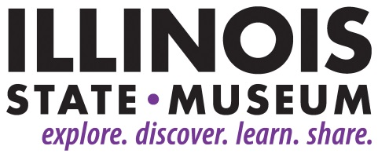

**FOR IMMEDIATE RELEASE**

October 22, 2019

**Contact:**

Sarah Davis

217-782-6044

Sarah.E.Davis@illinois.gov

**Illinois State Museum Super Saturday on Nov. 2 Celebrates National Bison Day**

*Children and families are invited to enjoy activities related to America’s National Mammal*

SPRINGFIELD, Ill. – The Illinois State Museum’s “Bison Bonanza” Super Saturday event will be just one stop on the 2nd Annual Bison Crawl to celebrate “National Bison Day” on November 2. From 11:00 a.m. to 3:00 p.m. children and their families will have the opportunity to handle bison fur and bones, view artifacts from the Museum’s collection, toss “bison chips,” and make bison-inspired art works.

The “Bison Bonanza” Super Saturday is being held in conjunction with the 2nd Annual Bison Crawl put on by local, state, and Federal partners throughout the Prairie State on November 2. The purpose of the Bison Crawl is to raise awareness of the historical significance of bison and their importance to prairie habitats. A full list of participating locations can be found at <https://www.fs.usda.gov/detail/midewin/news-events/?cid=FSEPRD670377>.

Super Saturday activities are recommended for children ages 5 and up and their caregivers. Activities take about 45 minutes to complete and are free with Museum admission. Super Saturdays are sponsored by Bank of Springfield.

For more information please contact Sarah Davis at [events@illinoisstatemuseum.org](mailto:events@illinoisstatemuseum.org) or 217-782-6044.

The Illinois State Museum is located at 502 S. Spring Street in Springfield. It is open Monday through Saturday from 9:00 a.m. to 4:30 p.m. and Sundays from 12:00 noon to 4:30 p.m. Admission is $5 for adults ages 19-64.

###