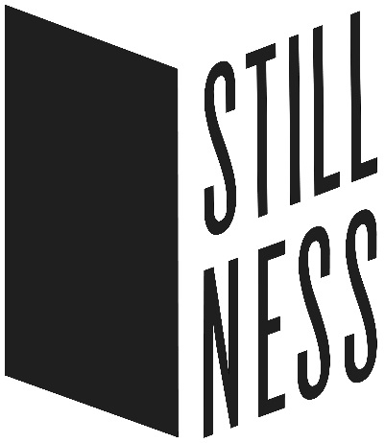

**FOR IMMEDIATE RELEASE**

February 26, 2018

**Contact:**

Doug Stapleton

Doug.Stapleton@illinos.gov

(773) 480-1060

***Stillness* Exhibition Set to Open at the Illinois State Museum on March 3, 2018**

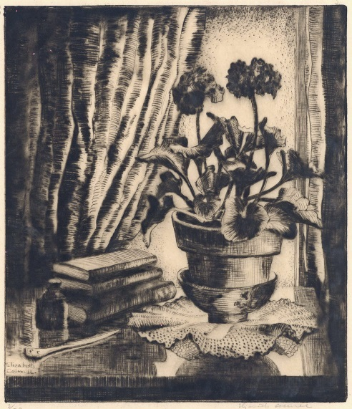SPRINGFIELD, IL -- *Stillness* is an exhibition that celebrates the genre of still life as a reflection of our modern life. This exhibition, which opens on March 3 at the Illinois State Museum in Springfield, brings together paintings, drawings, prints, photographs, and sculpture created over the last 100 years from the museum's permanent collection.

***Nancy Hild,*** *Happy Holidays,*

*1984, Illinois State Museum*

The works selected draw from significant movements and approaches to artmaking of the modern and contemporary periods. The artists selected have rendered their moments, real or imagined, in a variety of artistic approaches, from precise realism to gestural exuberance, all to singular effect. This tension between representation and abstraction—between holding on and letting go—is key, shuttling us between the unmoving, quiet moment and the energetic, often urgent measure of that experience.

***Elizabeth Colwell,*** *Primroses, c.1931, Illinois State Museum*

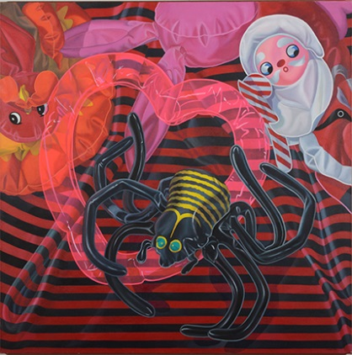Artists included: Macena Barton, Fred Becker, Fred Biesel, James Butler, Steven Carrelli, Elizabeth Colwell, Manierre Dawson, Michele Feder-Nadoff, Frances Foy, Gerald Frank, Susan Frankel, William Frederking, Minetta Good, Theodore Halkin, Nancy Hild, Ken Holder, Ben Mahmoud, Robert Middaugh, Jan Miller, Samuel Parker, Tom Petrillo, Carolyn Plochmann, Alejandro Romero, Frank Sadorus, Polly Scribner Ames, Flora Schofield, William Schwartz, Nicholas Sistler, Jeanette Pasin Sloan, Eric Wert, Albert Wong, Mary Agnes Yerkes.

The exhibition was organized by Associate Curator of Art Doug Stapleton and will run through June 3, 2018.  
  
The Illinois State Museum is open Monday through Saturday from 9:00 a.m. until 4:30 p.m. and Sunday from 12 noon until 4:30 p.m.  The Museum is located at 502 South Spring Street in Springfield.  Museum admission:  $5 for adults ages 19-64; free admission for children, seniors, and veterans.

###