**FOR IMMEDIATE RELEASE** **For more information contact:**

May 11, 2021 Jamila Wicks

P: 217.782.7388

[jamila.wicks@ismsociety.org](mailto:jamila.wicks@ismsociety.org)

**Museum Exhibition Celebrates Black Lives Through Art**

SPRINGFIELD, Ill. – The Illinois State Museum (ISM) is honored to present the exhibition *NOIR*opening Friday, May 28.The exhibition is a collaboration with Springfield’s Juneteenth, Inc., featuring works of art by artists of color from Illinois, Missouri, and Texas in celebration of Juneteenth.

“This new partnership sets the stage for the kinds of exhibits and community conversations we want to have and share at the ISM,” said Museum Director Cinnamon Catlin-Legutko. “The ideas and connections developed through this partnership with Juneteenth, Inc. have felt like a gift, and our commitment to the community has grown even stronger.”

Michelle “Micki” Smith and Korbin “KAS” King, both born and raised in Springfield, have joined together to guest curate this new exhibition and selected a slate of 20 talented artists to present a collection of 33 pieces of art celebrating Black lives, past, present, and future.

“I’m elated to be co-curating *NOIR* for the Illinois State Museum,” said King. “It gives me great honor and privilege to bring forth the upper echelon of emerging Black artists to represent Black excellence as a whole. Being a kid from the east side of Springfield, this is an experience beyond my wildest dreams.”

*NOIR* is the straightforward, simply put, and direct expression of the curators illustrated through the selected artists.

“This show, in this time in our lives, feels necessary,” said Smith. “We aim to display artwork by incredible artists while giving the viewer an experience that encourages a conversation long after the exhibition comes down, a call to action, even if it’s a personal change within.”

A panel on the history of Juneteenth will accompany the exhibition. The Museum plans to install the history panel, co-written by Juneteenth Inc.’s Cherena Douglass and Shymeka Gregory, on the exterior of its building located at 502 South Spring Street.

“Our goal is to increase community awareness about this significant moment in history,” said Gregory. “We want to demonstrate that Juneteenth is much more than a celebration in the park.”

The Museum will feature *NOIR* and the Juneteenth history panel through July. Admission is free. The exhibition will feature works of art from Zach Adams, Tyrell Bronner, Ebony Deshae, Alyssa Farmer, Marquis Jackson, Basil Kincaid, Korbin “KAS” King, Barbara Mason, Dale McReynolds, DeSande R, Brock Seals, Michelle Smith, Sherelle Speed, E.Vern Taylor, Obi Ukawe, Austin Wells, Jeff Williams, Bobby Williams, Jr., Wilma Wofford, and Norma Zuniga.

**About the Illinois State Museum**

Established in 1877, the Illinois State Museum is a dynamic institution that inspires the exploration of Illinois’ past and present to inform and enrich everyday life and promote stewardship of cultural and natural resources. Headquartered in Springfield with branch facilities in Lewistown and Lockport, ISM is accredited by the American Alliance of Museums and a proud member of the International Coalition of Sites of Conscience. For more information, visit [www.illinoisstatemuseum.org](http://www.illinoisstatemuseum.org).

###

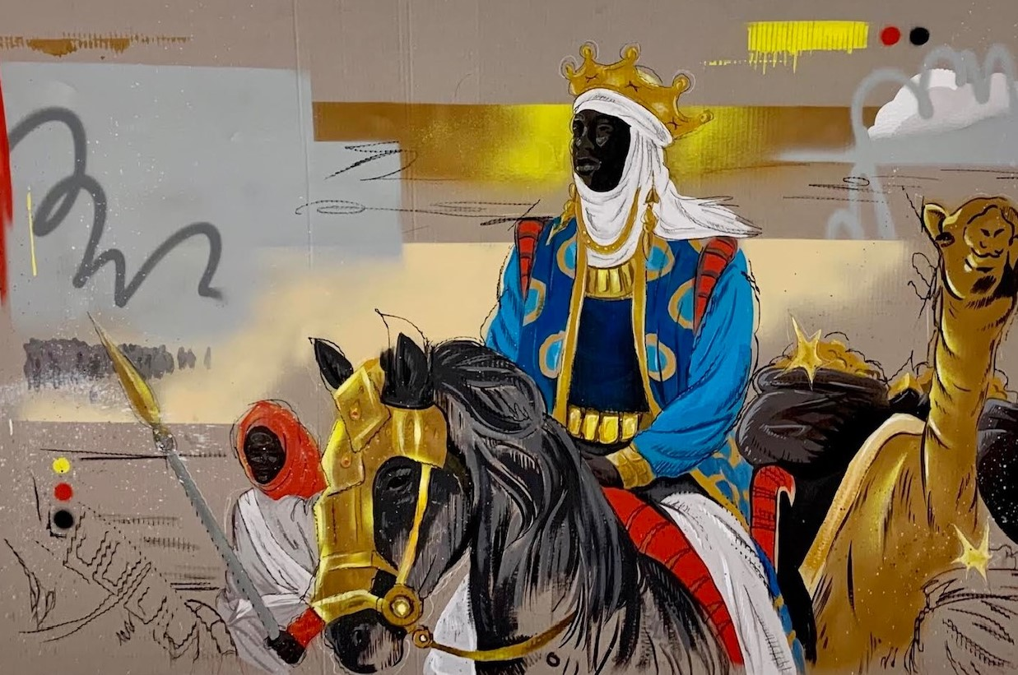

*Mansa Musa* byAustin Well

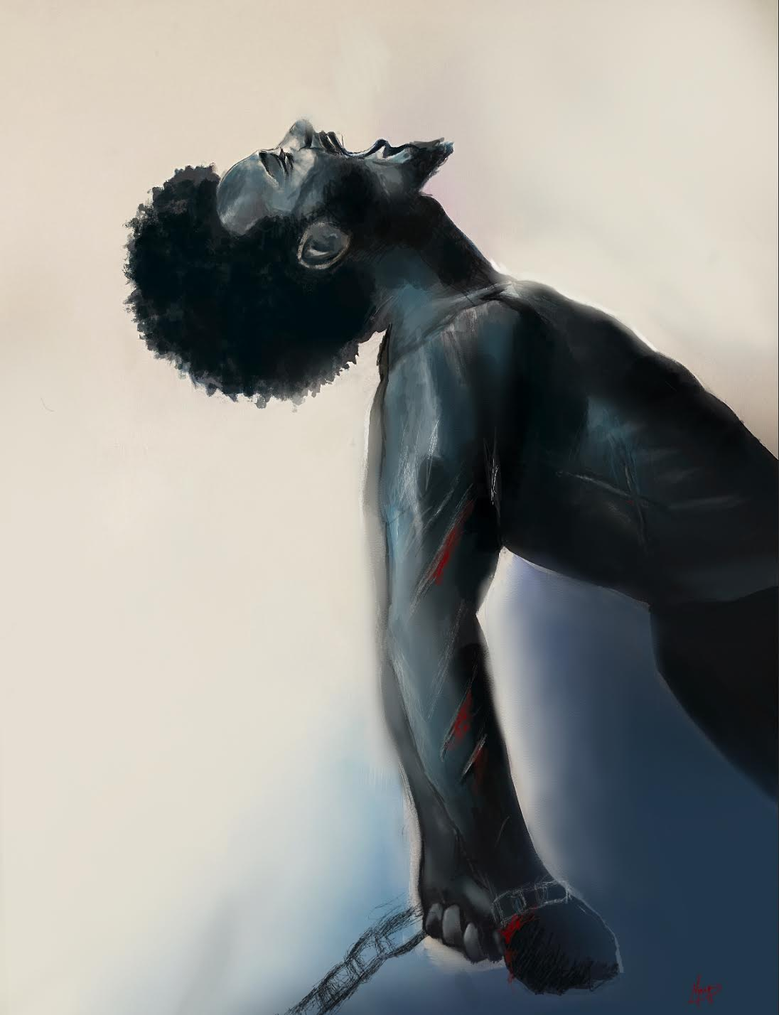

*Breaking Free* by Marquis Jackson